Budget Rent A Car 
of British Columbia

Global Information System

Fleet Control Business Design Business Design

Version 2.00

Note: The information contained in this document is confidential and may not be disclosed to any parties outside of Budget Rent a Car of British Columbia without written consent by one of its officers.
Copyright (C) 2000 Budget Rent a Car of British Columbia

Table of Contents
1. Functional Area Business Design 1
1.1. Fleet Control 1
1.1.1. Process Description 1
1.1.1.1. Receiving 2
1.1.1.2. Placement 3
1.1.1.3. Rental Use 3
1.1.1.4. Disposal 3
1.1.1.5. Fleet Inventory 5
1.1.1.6. Vehicle Status Information 6
1.1.1.7. Vehicle Licencing 7
1.1.2. Screens 9
1.1.2.1. Add Vehicle to Fleet 9
1.1.2.2. Vehicle Status Update 14
1.1.2.3. Vehicle Movement 18
1.1.2.4. Add Foreign Vehicle 26
1.1.2.5. Record Vehicle Service 30
1.1.2.6. Restrict Rental Use 36
1.1.2.7. Program Information Update 39
1.1.2.8. Vehicle Inventory 42
1.1.2.9. Licence Plate Inventory 50
1.1.2.10. Licence Plate Generation 54
1.1.2.11. Vehicle Search – Single Record 56
1.1.2.12. Vehicle Search Multiple records 58
1.1.2.13. Vehicle Model/Year 62
1.1.2.14. Vehicle Class Maintenance 65
1.1.2.15. Owning Company Maintenance 68
1.1.3. Reports 71
1.1.4. Test Scenario List 72
1.1.5. Controls & Audit Trails 73
1.1.6. Security Requirements 74
1.1.7. Business Transaction Volumes 75
1.1.8. Tables without Maintenance Screens 75
1.1.9. System Values Table Entries 75
1.1.10. Data Model 76
2. Revision History 77
2.1. Version 2.00 77

Functional Area Business Design

Fleet Control

Process Description
The business function of Fleet Control is to ensure that Budget has the correct number and types of vehicles in its inventory at the appropriate time. There are six major phases in the fleet life cycle at Budget.
- Planning – plan what vehicles to buy when to buy them and how to finance them.
- Ordering – place orders for vehicles with the manufacturers
- Receiving – take delivery of vehicles, place them into Budget’s fleet inventory and pay for them
- Placement – allocate vehicles for appropriate uses such as rental or lease.
- Rental or Lease Use – track location and status of vehicles during their lifetime at Budget
- Disposal – remove vehicles from the fleet inventory to be sold or returned to the manufacturer.
Budget BC makes all vehicle purchases for its rental operations. Vehicles are acquired from the vehicle manufactures through direct purchase (Risk Vehicles) or via turn back agreements (Program Vehicles). Currently, all trucks and some classes of cars are purchased as Risk Vehicles.

Risk Vehicles
Risk cars are normally kept for 1 ½ to 2 years and risk trucks are normally kept from 3 to 5 years. Both are sold through Budget Car Sales.

Program Vehicles
Program vehicles are kept for a shorter of time (normally 4-10 months) and then most are turned back to the manufacturer and some are kept by Budget as Risk vehicles. The period of time that the vehicles can be kept for and the maximum percentage of vehicles that can be kept by Budget BC at the end of that period are both defined in the purchase agreement with the manufacturer.
The sub-Licencees purchase their own risk vehicles and purchase all their program vehicles through Budget BC.
The sub-Licencees may also lease their vehicles from Budget BC. This arrangement is only available in special circumstances.
GIS provides the following facilities for the overall fleet control process:
- Maintenance screens for:
- Owning Company
- Vehicle Class
- Vehicle Model/Year
- Vehicle Search (Screens)
Two search functions for vehicles in the fleet. One is for a search that is expected to return multiple vehicles and one is for a search that is expected to return a single vehicle.

Receiving

Addition to Fleet Inventory
Vehicles purchased by Budget BC become part of Budget BC’s fleet inventory as soon as they are delivered to a Budget BC location.
GIS provides the following facilities for adding vehicles to the fleet inventory:
- Add Vehicle to Fleet (Screen)
This screen allows the rapid entry of multiple vehicles by retaining all non-unique fields on the screen after a vehicle has been added. The user will then enter the unique information for the next vehicle only changing the non-unique fields when necessary.
- Record the fact that PDI has been started through the Vehicle Status Update screen.
- Record the fact that PDI has been completed through the Vehicle Status Update screen.
- Add Foreign Vehicle (Screen)
This screen allows the addition of foreign vehicles that arrive at Budget BC via a contract check in or a vehicle movement.

Transfer of Ownership
Budget BC assumes ownership of a vehicle by signing the ownership document for that vehicle and by putting Licence plates and an insurance decal on the vehicle. Once Budget has assumed ownership of a vehicle, insurance coverage on the vehicle commences immediately.
GIS provides the following facilities for the ownership transfer process:
- The ability to transfer ownership through the Add Vehicle to Fleet screen or through the Licence Plate Inventory screen.

Payment
The first phase of GIS will not provide facilities for the payment process.

Placement
Once a vehicle is owned by Budget, it can be allocated for use as a lease or a rental vehicle.
The calculation of depreciation expenses will not start until the vehicle is allocated for a specific use. In some cases, Budget BC may decide to hold a risk vehicle for a period of time without using it. This happens when the market conditions are not what Budget was planning for when they placed the order. As a result, Budget BC may decide to sell the vehicle and will hold it without using it until in order to maximize the resale value.
GIS provides the following facilities for vehicle placement:
- Vehicle Status Update (Screen)
  - Record the allocation of a vehicle or group of vehicles for use as a rental or lease vehicle.
  - Record a vehicle or group of vehicles being held for possible resale.

Rental Use
Once a vehicle is allocated for rental use it can be moved between locations, rented on contracts and returned from rental. The contract function will handle the rental and return of vehicles on contracts.
The fleet system will provide the following functions to support rental use:
- Vehicle Movement (screen)
A facility to record vehicle movement.
- Vehicle Service (screen)
A facility to record vehicle service after a check in.

Disposal
Vehicles can be disposed of in one of three ways. They can be turned back, sold or written off.

Turned Back
Most program vehicles are turned back to the manufacturer under the terms of the Purchase Agreement. The purchase agreement usually specifies a maximum percentage of program vehicles that can be kept by Budget BC as risk vehicles at the end of the program term. Budget will keep some or all of these vehicles and the rest will be turned back to the manufacturer. Vehicles that are written off are included in the percentage count of risk vehicles.
The turn back terms vary between agreements, but they have both time and kilometre limits and generally take the following form.
- Minimum and Maximum Time Period (e.g. 7 to 12 months) – if the maximum limit is exceed the vehicle becomes one of the risk vehicles allowed for in the turn back agreement
- Turn Back Deadline Date (e.g. March 21, 1999)– a fixed calendar date which overrides the maximum time limit
- Number of Free Kilometres (e.g. 39,000)
- Maximum Number of Kilometres (e.g. 45,000) – if this limit is exceed the vehicle becomes one of the risk vehicles allowed for in the turn back agreement
- Number of days allowed for turn back servicing (e.g. 7)
When a vehicle is due for turn back, it is pulled from rental or lease use and returned to Budget BC’s main location. Once the vehicle is returned, the plates are removed and the turn back papers are signed, and the vehicle is then shipped to the location specified by the manufacturer.
The new system will provide the following facilities to support the turn back process:
- Include information about approaching turn back limits when presenting a list of available vehicles at contract check in time. For details, see the contract function.
- Update Program Information (screen)
Update the program information and turnback deadlines for a vehicle or a group of vehicles.
- Restrict Rental Use (screen)
Restrict the rental use of a vehicle or group of vehicles to certain location(s) and/or a maximum rental period.
- Record the fact a vehicle has been pulled in for disposal through Vehicle Status Update screen.
- Record the fact that disposal servicing has been completed through the Vehicle Status Update screen.
- Record the fact that the turn back papers for a vehicle have been signed through Vehicle Status Update screen.

Sold
Risk vehicles and some program vehicles are sold at the end of their rental or lease use.
When a vehicle is due to be sold, it is pulled from rental or lease use and returned to Budget BC’s main location.
Once the vehicle is returned, the plates are removed and the vehicle is shipped to the purchaser.
The new system will provide the following facilities to support the sales process:
- Record the fact a vehicle has been pulled in for disposal through Vehicle Status Update screen.
- Record the fact that disposal servicing has been completed through the Vehicle Status Update screen.
- Record the fact a vehicle has been sold through Vehicle Status Update screen.

Written Off
Some vehicles are written off after being stolen or damaged in accidents.
The new system will provide the following facilities to support the write off process:
- Record the fact a vehicle has been stolen through Vehicle Status Update screen.
- Record the fact a vehicle has been damaged beyond repair in an accident through Vehicle Status Update screen.
- Record the fact a vehicle has been written off through Vehicle Status Update screen.

Fleet Inventory
GIS provides the ability to store and retrieve information for Vehicle Models and individual Vehicles on GIS.

Vehicle Status Information
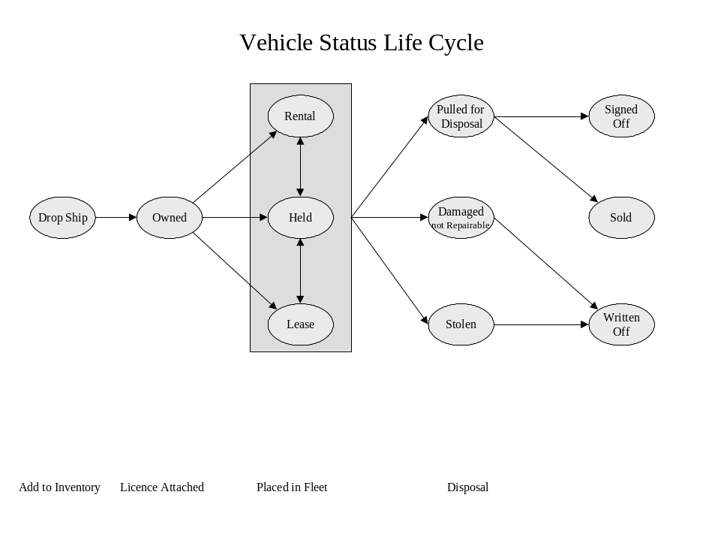
- Vehicle Statuses
The vehicle status indicates what stage a vehicle is at in its life cycle in terms of ownership and usage. The following vehicle statuses will be confirmed in the business design phase:
- Drop Ship – The vehicle has been delivered to a Budget BC or sub-Licencee location, either directly from the manufacturer or via a dealer.
- Rental – The vehicle is being used as a rental vehicle. Depreciation starts at this point.
- Held – The vehicle is being held without being used in order to maximize its resale value.
- Lease – The vehicle is being used as a lease vehicle. Depreciation starts at this point.
- Pulled for Disposal – The vehicle has been pulled from rental or lease use and returned to the main Budget location for turn back or pre-sale servicing. Third-party insurance coverage stops at this point.
- Damaged: Not Repairable – The vehicle has been in an accident and cannot be repaired. Third-party insurance coverage stops this point.
- Stolen – The vehicle has been stolen for more than six months. Third-party insurance coverage stops at this point.
- Signed Off – The vehicle has been returned to the manufacturer under a turn back agreement. Depreciation stops at this point less the number of days allowed for turn back servicing.
- Sold – The vehicle has been sold. Depreciation stops at this point.
- Written Off – The vehicle has been written off (destroyed in an accident or stolen and not recovered). Depreciation stops at this point.
- Vehicle Rental Statuses
The vehicle status indicates what stage a vehicle is currently at in its rental usage. The following vehicle statuses will be confirmed in the business design phase:
- Available – The vehicle is available to be rented. The rental status will be set to Available when the vehicle is first allocated for rental and every time it is checked in on a contract.
- On Rent – The vehicle is currently being rented and cannot be rented again until is returned. The rental status will be set to On Rent every time the vehicle is checked out on a contract.
- In Transit – The vehicle is currently being moved.
- Vehicle Condition Statuses
The vehicle condition status indicates what physical condition a vehicle is currently in. The following vehicle statuses will be confirmed in the business design phase:
- OK: The vehicle can be rented or leased.
- Damaged: Not Drivable – The vehicle is damaged and cannot be safely driven.
- Damaged: Not Rentable – The vehicle is damaged and cannot be rented again until it is repaired.
- Damaged: Rentable – The vehicle is damaged, but can be rented if necessary.
- O/S: Not Rentable – The vehicle is out of service due to mechanical problems and cannot be rented again.
- O/S: Rentable – The vehicle is out of service due to mechanical problems, but can be rented if necessary.
- Maintenance: Not Rentable – The vehicle needs maintenance and cannot be rented again until it has been done.
- Maintenance: Rentable – The vehicle needs maintenance, but can be rented if necessary.
- Stolen: The vehicle is missing or stolen and cannot be rented again.
These statuses will be set by the contract, maintenance and claims functions.

Vehicle Licencing
Budget BC purchases Licence plates from the BC department of motor vehicles via an ICBC insurance agent. They are attached to new vehicles when Budget BC takes ownership of them and recycled when the vehicles are disposed of.
GIS provides the following inventory and tracking facilities for vehicle Licencing:
- Vehicle Licence Inventory (Screen)
Allows viewing of licence plate history and the addition and removal of vehicle licence plates.
- Create Sequential Licence Plates (Screen)
Create a new set of Licence plate entries using the starting and ending numbers of a series.
- Licence Plate Search (Part of Vehicle Search Screen)
Identify what vehicle a Licence plate was attached to at any point in time or for a given time period.

Screens

Add Vehicle to Fleet
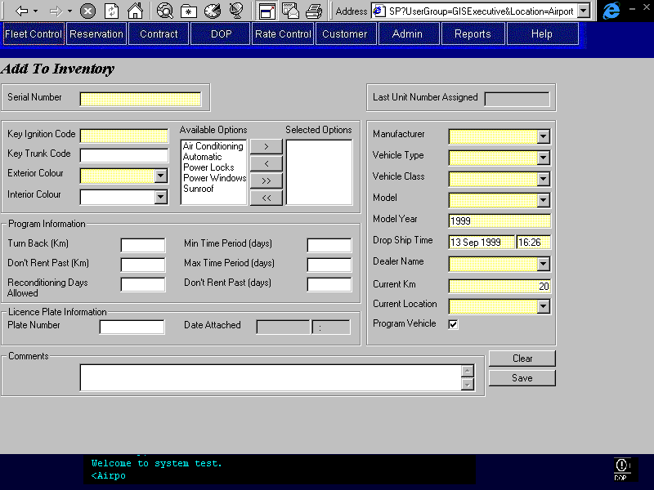

Purpose
The Add Vehicle to Fleet screen is used to enter information for each vehicle into the system as the vehicles are delivered to Budget.
The user enters the Serial Number for each vehicle. The Key Ignition Code, Key Trunk Code (optional), Exterior Colour, Interior Colour (optional), and Current Km, are changed as necessary as each vehicle is added. The user can also select vehicle options to associate with each vehicle. The Manufacturer, Vehicle Type, Vehicle Class, Model, Model Year, Drop Ship Date, Dealer Code, Dealer Name, Current Location, Program Vehicle identifier and Turn Back information are only entered for each group of vehicles added. When the form is complete the user presses the Save button to add the vehicle to the system.
The system adds the vehicle with the Vehicle Status, Drop Ship and the Status Date, Drop Ship Date. The form then displays with only the Serial Number and Key Ignition Code field blanked out and the next available Unit Number and the remaining fields retaining their previous values. In this way when two identical vehicles are added one after the other, the only fields that will always need to be filled out for the second vehicle are the Serial Number and the Key Ignition Code. The user enters the Serial Number and then presses the Tab key and then enters the Key Ignition Code. The user presses Tab between each field and enters the Key Trunk Code, Exterior Colour, Interior Colour, and Licence Plate Number, as these are the most commonly changing fields.
This screen also allows the user to perform the Ownership Transfer function if this has already taken place when the vehicle is being added to inventory. This function can also be performed in the Licence Inventory screen if the Ownership Transfer takes place subsequent to adding the vehicle to inventory. If the Licence Plate number is already in use on another vehicle the system will warn the user “This Licence Plate is associated with Unit # XXXXXX”. The user would then enter another licence plate or use the Licence Inventory screen to remove the licence from the other vehicle before adding it to the new vehicle.

Navigation

NA

Functions
Save Saves the current record to the Vehicle Table along with any options. The Unit Number assigned will be displayed in a dialog box if the save is successful and in the Last Unit Number Assigned text box.
A record will also be written to the Vehicle Status History Table with the Unit Number, the Vehicle Status of “Drop Ship” and the Drop Ship Date. If the Ownership Transfer Information is completed then the Vehicle Status will be updated to “Owned” with the Ownership Date and another entry will be written to the Vehicle Status History Table. Additionally, the Licence plate on the vehicle would have the Unit Number and Date Added fields added to it.
A vehicle movement will be created to move the vehicle from the Non-Budget location to the Current Location.

Controls
 | Field | Source | Req* | Validation | Comments
 | Serial Number | Vehicle, Serial Number | Y | Must be exactly 17 characters long, must be unique
 | Last Unit Number Assigned | Vehicle, Unit Number | D | 6 digits | Displays the last Unit # assigned when a record is saved.
 | Key Ignition Code | Vehicle, Key Ignition Code | Y |  | most are 7 digits, space for 10
 | Key Trunk Code | Vehicle, Key Trunk Code | N |  | most are 7 digits, space for 10
 | Exterior Colour | Vehicle, Exterior Colour | Y | Value controlled by lookup table
 | Interior Colour | Vehicle, Interior Colour | N | Value controlled by lookup table
 | Installed Options | Vehicle Installed Option, Vehicle Option ID | N | Value controlled by Vehicle Options Table | Accumulator
 | Manufacturer | Vehicle Model Year, Manufacturer | Y | Value controlled by lookup table
 | Vehicle Type | Vehicle Class, Vehicle Type | Y | Value controlled by Vehicle Type table
 | Vehicle Class | Vehicle Model Year, Vehicle Class Code | Y | Value controlled by Vehicle Class table | Dependant on Vehicle Type
 | Model | Vehicle, Vehicle Model ID | Y | Value controlled by Vehicle Model Year Table excluding Foreign Models | Dependant on Manufacturer, Vehicle Type and Vehicle Class
 | Model Year | Vehicle Model Year, Model Year | Y | Value controlled by Vehicle Model Year Table excluding Foreign Models
 | Drop Ship Date | Vehicle History, Effective On where Status = “Drop Ship” | Y | Date/Time Format | Default to current date & time.
 | Dealer Name | Vehicle, Dealer Code | Y | Value controlled by lookup table
 | Current Km | Vehicle, Current Km | Y |  | Defaults to 20
 | Current Location | Vehicle, Current Location ID | Y | Value controlled by Location table
 | Program | Vehicle, Program | N |  | Default: Yes Program if checked otherwise Risk
 | Turn Back (Km) | Vehicle, Maximum Km | N
 | Don’t Rent Past (Km) | Vehicle, Do Not Rent Past (Km) | N |  | e.g., Turn Back Km less 500
 | Reconditioning Days Allowed | Vehicle, Reconditioning Days Allowed | N
 | Min Time Period (days) | Vehicle, Minimum Days | N
 | Max Time Period (days) | Vehicle, Maximum Days | N
 | Don’t Rent Past (days) | Vehicle, Do Not Rent Past Days | N
 | Plate Number | Vehicle Licence History, Licence Plate Number;  Vehicle, Current Licence Plate | N | AAA 999 OR 9999 AA Format Must be in Licence Table, must not be attached to another vehicle | The Licencing Province will be set to BC. (Vehicle Licence History, Licencing Province/State; Vehicle, Current Licencing Province/State)
 | Date | Vehicle Licence History, Attached On;  Vehicle, Licence Plate Attached On | S | Date/Time Format  Cannot be less than Drop Ship Date. | Ownership Transfer Status Date, required when Licence Plate Number is entered Default to current Date & Time.
 | Comments | Vehicle, Comments | N |  | Any additional information (e.g., keyless entry code)
Technical Notes
Owning Company: Since foreign vehicles are added through a separate screen the Owning Company will always be Budget BC. This field should be set when the record is saved.
Licencing Province: Again, since this will always be BC, this should be set in the Vehicle Licence History entity when the record is saved.
Save: Save the vehicle record first, setting the Owning Company to Budget BC. Then save the entry to the Vehicle History table for “Drop Ship” and the Drop Ship Date, and if necessary save the entry for “Owned” and the Transfer of Ownership Date. If there are any associated options with the vehicle save them next to the Vehicle Installed Option table. Finally, if necessary, save the Licence Plate entry to the Vehicle Licence History entity. If the Licence doesn’t exist in the Vehicle Licence Plate table display an error message to the user. If the Licence Plate is already associated to another vehicle display an error message stating “the Licence Plate is already associated to Unit Number #######, enter another plate or remove the plate from this vehicle”.
Create a Vehicle Movement for the vehicle as follows:
Movement Out Drop Ship Date (date & time)
Km Out Current Km
Sending Location ID Non- Budget Location
Movement In Drop Ship Date (date & time)
Km In Current Km
Receiving Location ID Current Location
Driver Name ‘N/A’
Approver Name ‘N/A’
Billable No
Movement Type ‘Drop Ship’

Vehicle Status Update

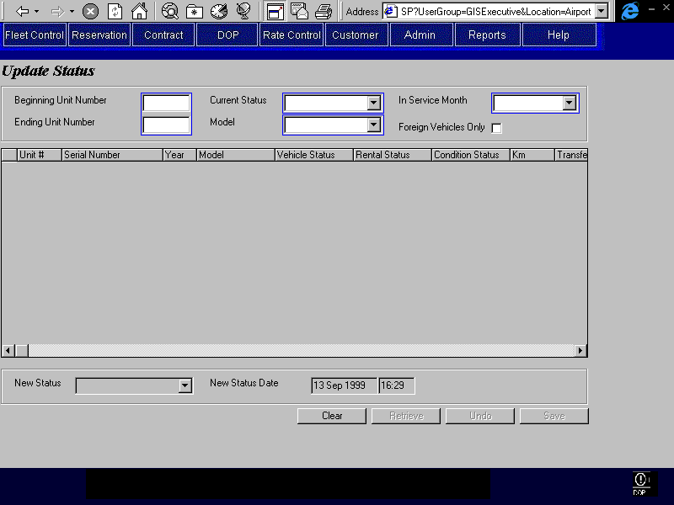

Purpose
The purpose of this screen is to allow the updating of multiple vehicles’ current vehicle status. This screen allows the user to display information about a group of vehicles within a unit number range or with the same model and current status. From this listing of vehicles the user can select multiple entries and update the status for all selected vehicles. For certain Status updates additional information is required; this additional field will only be visible when the status that requires them is selected. For example, if “Pulled for Disposal” is selected then the Remove Licence checkbox becomes visible and enabled, otherwise it is not displayed. Vehicles with a current status of “Drop Ship” can not be updated in this screen, but can be updated to “Owned” in the Licence Inventory screen.

Functions
Retrieve: Retrieves vehicle records that meet search criteria, within Unit Number range or model and current status, and populates grid.
Save: Updates selected vehicles with new status and status date. Depending on which new status is selected the system will display an additional field and or save additional fields to the vehicle records selected. See Technical Notes below.

Controls
 | Field | Source | Req* | Validation | Comments
 | Beginning Unit Number | Vehicle, Unit Number | S | 6 digits Searchable | When entered Ending Unit Number must also be entered
 | Ending Unit Number | Vehicle, Unit Number | S | 6 digits Searchable | When entered Beginning Unit Number must also be entered
 | Current Status | Vehicle, Current Vehicle Status | S | Value controlled by Vehicle Status table Where Status <> “Drop Ship” | When Unit Number Range not entered one of Current Status, Model, or In Service Month is required
 | Model | Vehicle, Vehicle Model ID | S | Value controlled by Vehicle Model Year table | When Unit Number Range not entered one of Current Status, Model, or In Service Month is required
 | In Service Month | Vehicle, Ownership Date | S | MMM YYYY Format | Populate the dropdown with months for the last two years from the current month
 | Foreign Vehicles Only | Vehicle, Foreign Unit Number | N
 | Unit Number | Vehicle, Unit Number | D
 | Serial Number | Vehicle, Serial Number | D
 | Model Year | Vehicle Model Year, Model Year | D
 | Model | Vehicle Model Year, Model Name | D
 | Vehicle Status | Vehicle, Current Vehicle Status
 | Rental Status | Vehicle, Current Rental Status | D
 | Condition Status | Vehicle, Current Condition Status | D
 | Current Km | Vehicle, Current Km | D
 | Transfer Date | Vehicle History, Effective On | D |  | Where Vehicle Status = “Owned”
 | Location | Vehicle, Current Location ID | D
 | Licence | Vehicle, Current Licence Plate | D
 | New Status | Vehicle, Current Vehicle Status and Vehicle History, Vehicle Status | Y | Value controlled by Vehicle Status table | Cannot update the Vehicle, Current Status from Rental to Rental.
 | Date | Vehicle, Vehicle Status Effective On and Vehicle History, Effective On | Y | Date/Time Format | Default to System Date/Time
 | Remove Licence |  | N | If Yes, vehicle cannot have a rental status of “In Transit” and cannot have a rental status of “On Rent” unless a vehicle not present check in has been done by vehicle support. | Visible only when New Status is “Pulled for Disposal”  Defaults to true
Technical Notes
A maximum of 100 vehicles can be updated at one time.
If the new status is “Rental” then the system also updates Rental Status to “Available” and the Rental Status Date to New Status Date and the vehicle Condition Status is set to “OK” and the Condition Status Date to New Status Date.
If the new status is “Pulled for Disposal” or “Damaged: Not Repairable” then the Remove Licence checkbox is displayed. If the user selects Remove Licence then the system will remove the Licence attached to each vehicle. This updates the Licence entity by adding the Removed Date to the record for that vehicle.
If the new status is “Sold”, “Signed Off”, or “Written Off” then check that all selected vehicles do NOT have a licence plate still attached to them and display an error message if any vehicles do.
The following table summarizes the additional fields set and displayed during status updates.

Status Update Exceptions
 | New Status | Additional Fields Set | Additional Fields Displayed
 | Rental | Current Rental Status = “Available”  Rental Status Effective On = Date  Current Condition Status = “OK”  Condition Status Effective On = Date
 | Pulled for Turn Back |  | Remove Licence checkbox
 | Pulled for Sale |  | Remove Licence checkbox
The new status cannot be set to “Sold”, Written Off” or “Signed Off” if any of the vehicles selected still has a licence plate attached to it. The new status cannot be set to “Rental” if the current vehicle status is “Rental”.

Vehicle Movement
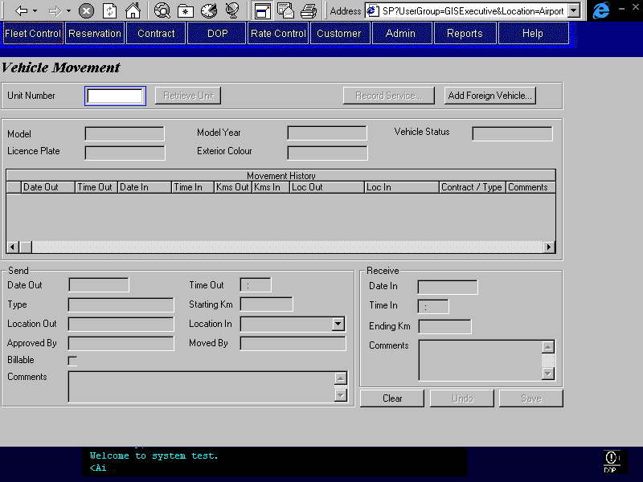

Purpose
The vehicle movement screen allows entry of a vehicle movement into the system. Vehicle movements are used to keep track of the vehicle’s location and update the total non-revenue kilometres.
Recording a Vehicle Movement – Will be a two part process:
- Send – the user will enter the unit # and the system will display the following:
- Model and Year
- Licence Plate Number
- Exterior Colour
- Current Vehicle Status
- Last 4 transactions – Movement History

If the Unit is nearing its turn back limits in either time or kilometres then the system will display a warning message informing the user of the number of kilometres or days left before turn back or sale. See Technical Notes for a table of warning messages.
The user will then enter the following information;
- Date Out
- Time Out
- Approved By
- Moved By
- Location In
- Starting Km
- Billable – Yes/No
- Comments – comments regarding the movement
Movement Type and Location Out are set to the Vehicle’s current Condition Status and Current Location.
- Receive – the user will enter the Unit # and the system will display the following;
- Date Out
- Time Out
- Movement Type
- Location Out
- Approved By
- Moved By
- Location In
- Starting Km
- Billable (was Revenue Generating Flag) Yes/No
- Comments
The user will then enter the following information:
- Date In
- Time In
- Ending Km
- Comments – The user could append remarks but not edit existing remarks
The system will then update the vehicle’s current location to the receiving location and the total non-revenue Km to include the difference between the Ending and Starting Km readings.

Navigation
Record Service: Opens the Record Vehicle Service screen and populates the screen with the current Unit number.
Add Foreign Vehicle: Opens the Add Foreign Vehicle screen to allow for the addition of a Foreign Vehicle to Inventory.
Contract Check-in Opens the override Contract check-in screen so that the vehicle can be checked in on it’s current contract. Invoked when the vehicle retrieved is currently checked out on a contract.

Functions
Retrieve Unit: Retrieves the vehicle record and four most recent movements for the vehicle that matches the Unit Number. If there is already an open vehicle movement for that vehicle it will display in the send side of the screen and will have to be closed before another send can be created. If the vehicle is currently on contract the Override Check In screen will be opened.
Save: Creates an open Vehicle Movement or closes an already open vehicle movement. See Technical Notes.

Controls
 | Field | Source | Req* | Validation | Comments
 | Unit Number | Vehicle, Unit Number | Y | 6 digits Searchable
 | Model | Vehicle, Vehicle Model ID  Vehicle Model Year, Model Name | D
 | Licence Plate | Vehicle, Current Licence Plate | D
 | Model Year | Vehicle, Vehicle Model ID; | D |  | Display Model Year
 | Exterior Colour | Vehicle, Exterior Colour | D
 | Vehicle Status | Vehicle, Current Vehicle Status | D
 | Movement History
 | Date Out | Contract:  Vehicle On Contract, Checked Out  Movement:  Vehicle Movement, Movement Out | D
 | Time Out | Contract:  Vehicle On Contract, Checked Out  Movement:  Vehicle Movement, Movement Out | D
 | Date In | Contract:  Vehicle On Contract, Acutal Check In or Expected Check In  Movement:  Vehicle Movement, Movement In | D |  | For Contract: Use Vehicle On Contract, Actual Check In if populated, otherwise use Expected Check In
 | Time In | Contract:  Vehicle On Contract, Actual Check In or Expected Check In  Movement:  Vehicle Movement, Movement In | D |  | For Contract: Use Vehicle On Contract, Actual Check In if populated, otherwise use Expected Check In
 | Kms Out | Contract:  Vehicle On Contract, Km Out  Movement:  Vehicle Movement, Km Out | D
 | Kms In | Contract:  Vehicle On Contract, Km In or Override Check In, Km In  Movement:  Vehicle Movement, Km In | D |  | For Contract: Use Vehicle On Contract, Km In if populated otherwise use Override Check In, Km In if populated. If neither populated leave blank.
 | Location Out | Contract:  Vehicle On Contract, Pick Up Location ID  Movement:  Vehicle Movement, Sending Location ID | D
 | Location In | Contract:  Vehicle On Contract, Actual Drop Off Location ID or Expected Drop Off Location Id  Movement:  Vehicle Movement, Receiving Location ID | D |  | For Contract: Use Vehicle On Contract, Actual Drop Off Location ID if populated, otherwise use Expected Drop Off Location ID
 | Contract # or Movement type | Contract:  Vehicle On Contract, Contract Number  Movement:  Vehicle Movement, Movement Type | D
 | Comments | Vehicle Movement, Remarks Out and Remarks In | D
 | Send User Input
 | Date Out | Vehicle Movement, Movement Out | Y | Date Format  Date/Time Out must be greater than the last Date/Time In shown in the Movement History unless an override check in has been done. In that case Date/Time Out must be greater than the Date/Time Out for the contract being overridden. | Check Do Not Rent Past Days display warnings if necessary  Default to System Date
 | Time Out | Vehicle Movement, Movement Out | Y | General Time Format | Default to System time
 | Type | Vehicle, Current Condition Status | D
 | Starting Km | Vehicle Movement, Km Out | Y | Defaults to Vehicle, Current Km | Check Turn Back Km display warnings if necessary
 | Location Out | Vehicle Movement, Sending Location ID | D |  | Set to Vehicle, Location ID  Location Name is displayed.
 | Location In | Vehicle Movement, Receiving Location ID | Y | Value controlled by Location Table | Location Name is displayed.
 | Approved By | Vehicle Movement, Approver Name | Y
 | Moved By | Vehicle Movement, Driver Name | Y
 | Billable | Vehicle Movement, Billable | N
 | Comments | Vehicle Movement, Remarks Out | N
 | Receive User Input
 | Date In | Vehicle Movement, Movement In | S | Date Format | Required for receive portion of Movement  Disabled when CSR is not at Receiving Location or a non-rental location.
 | Time In | Vehicle Movement, Movement In | S | General Time Format | Required for receive portion of Movement  Disabled when CSR is not at Receiving Location or a non-rental location.
 | Ending Km | Vehicle Movement, Km In | S | Must be => starting km | Required for receive portion of Movement  Disabled when CSR is not at Receiving Location or a non-rental location.
 | Comments | Vehicle Movement, Remarks In | N |  | Disabled when CSR is not at Receiving Location or a non-rental location.
Technical Notes
The movement history comprises two different transactions. A contract, where the contract number will be displayed, and a vehicle movement, where the movement type will be displayed. All other information, date out, time out, date in, time in, kilometres out, kilometres in, location out, and location in will be stored for both transaction types.
A CSR (Customer Service Rep) at the receiving location can fill in both the send and receive portions of the movement. A CSR at the sending location can fill in only the send portion. When filling in the receive portion of a movement the CSR can update the Location In field in the send portion but no other fields.
When entering a Unit # for a vehicle currently on contract the Override Check In screen is opened to allow the CSR to check in the current contract. Unless this is done, the CSR will not be able to enter a movement for the vehicle.
Additional fields that are set on a vehicle receive include;
 | Field | Set To
 | Vehicle, Current Location ID | Location In
 | Vehicle, Current Km | Km In
 | Vehicle, Total Non-Revenue Km | (Total Non-Revenue Km + (Km In – Km Out)) Do Not Set if Billable = True
Warning Messages: As vehicles approach the Do Not Rent Past amounts these messages display for Vehicle Movement and Contracts. The formulas for calculating the Range are;
For Km Warnings; Do Not Rent Past Km – Current Km = x
For Days Warnings; Do Not Rent Past Days – (Todays(Date) –Ownership Date) = y
 | Range | Message
 | =<2000km >1000km | REMINDER! This vehicle has only x km left. Not suitable for long term and/or long trip rental.
 | =<1000km >500km | WARNING! This vehicle has only x km left and should be used for local and/or short rental only.
 | =<500km >250km | WARNING! This vehicle has only x km left and is ready for turnback or car sales. Call DOP or FLEET for approval on rental in critical condition.
 | =<250km | WARNING! This vehicle has only x km left and is ready for turnback or car sales.  RESTRICTION ON THE CONTRACT, ALLOW MOVEMENT ONLY
 | Range | Message
 | =<30 days >20 days | REMINDER! This vehicle has only y days left. Not suitable for long term and/or long trip rental.
 | =<20 days >15 days | REMINDER! This vehicle has only y days left. Not suitable for long term and/or long trip rental.
 | =<15 days >10 days | WARNING! This vehicle has only y days left and should be used for local and/or short rental only.
 | =<10 days >5 days | WARNING! This vehicle has only y days left and is ready for turnback or car sales. Call DOP or FLEET for approval on rental in critical condition.
 | =<5 days | WARNING! This vehicle has only y day(s) left and is ready for turnback or car sales.  RESTRICTION ON THE CONTRACT, ALLOW MOVEMENT ONLY

Add Foreign Vehicle
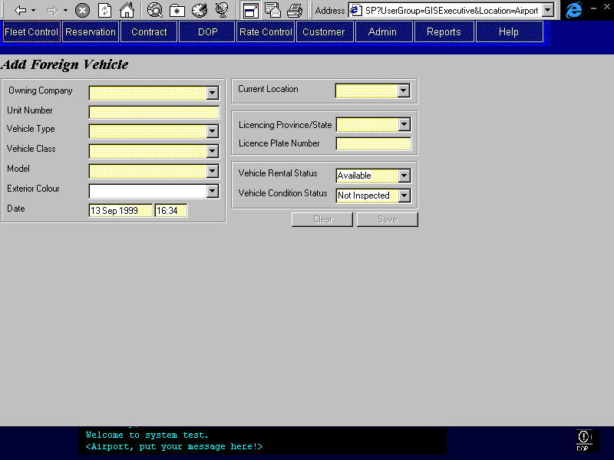

Purpose
The Add Foreign Vehicle screen allows for the entry of Foreign Vehicles into the GIS system. The system tracks only a subset of vehicle information for Foreign Vehicles and certain fields that are defaulted for local vehicles are required for Foreign Vehicles. For example, Turn Back information is required for Budget BC vehicles but not tracked for Foreign Vehicles, also Licencing Province/State and Owning Company are defaulted to BC and Budget BC for all vehicles except Foreign Vehicles where these fields must be entered by the user.

Navigation

NA

Functions

NA

Controls
 | Field | Source | Req* | Validation | Comments
 | Owning Company | Vehicle, Vehicle Owning Company | Y | Value controlled by Owning Company Table | Display Owning Company, Name
 | Unit Number | Vehicle, Foreign Unit Number | Y | 6 digits | Foreign Vehicle Unit #
 | Vehicle Type | Vehicle, Vehicle Model ID; | Y | Value controlled by Vehicle Type Table | Car, Truck, etc.  Vehicle Class, Vehicle Type associated with the Vehicle Model ID
 | Vehicle Class | Vehicle, Vehicle Model ID; | Y | Value controlled by Vehicle Class Table | Economy, compact, etc.  Vehicle Model Year, Vehicle Class Code associated with Vehicle Model ID.
 | Model | Vehicle, Vehicle Model ID; | Y | Value controlled by Vehicle Model Year Table | Can enter a new model not currently in model table.  Display Model Name
 | Exterior Colour | Vehicle, Exterior Colour | N | Value controlled by Lookup, Exterior Colour | Can enter a new colour not currently in code table
 | Date | Vehicle, Status Effective On;  Vehicle, Rental Status Effective On;  Vehicle, Condition Status Effective On;  Vehicle History, Effective On;  Condition History, Effective On | Y | Date/Time Format | Where vehicle status is saved as Rental.
 | Current Location | Vehicle, Current Location ID | Y | Value controlled by Location Table | Default to CSR’s current location
 | Licencing Province/State | Vehicle, Current Licencing Province/State | Y | Value controlled by Lookup Table
 | Licence Plate Number | Vehicle, Current Licence Plate | Y |  | Not saved to Licence Plate inventory e.g. Vehicle Licence Plate table
 | Rental Status | Vehicle, Current Rental Status | Y | Value controlled by Rental Status Table | Default: Available
 | Vehicle Condition Status | Vehicle, Current Condition Status | Y | Value controlled by Vehicle Condition Status Table | Default: Not Inspected
Technical Notes
Automatically adds new model to the vehicle model year table as foreign models. These foreign models require only the model name and vehicle class. Retrieval of models to populate the dropdown on this screen will get unique model names where the model year is most recent. These foreign only models will not show up on the reservations screen in the list of available models.
The Foreign Unit Number will be saved to the Vehicle Foreign Unit Number field and the Vehicle Unit Number will be the next available Budget Unit Number. On all Unit Number searches matching Unit numbers will be returned where the Foreign Unit Number is Null. Where the Foreign Unit Number is not null it will return when the Foreign Unit number matches the search criteria. An example appears in the Technical Notes for Record Vehicle Service.
When a new foreign vehicle is added a validation based on the Foreign Unit Number, Owning Company, and Delete Flag will be done to ensure that the vehicle does not already actively exist in the database.

Record Vehicle Service
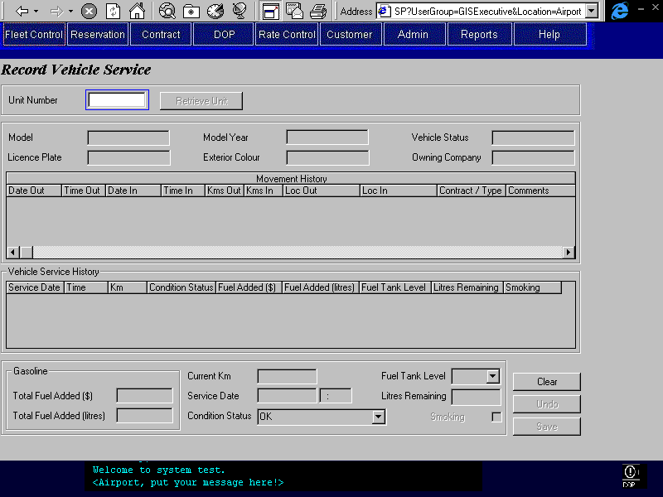
Purpose
The purpose of this screen is to record the details of vehicle servicing performed after contract check–in or vehicle movement.
The user will enter the following data:
- Unit Number – will be used to retrieve the current vehicle information and to apply the new information to the proper vehicle record
If the vehicle model denotes a gas model the user would enter:
- Total Fuel Added ($)– will be used by the close contract function for fuel adjustments, Or,
- Total Fuel Added (litres)– will be used by the close contract function to calculate the dollar amount for fuel adjustments
If the vehicle model denotes a diesel vehicle the user would enter:
- Total Diesel Added ($)– will be used by the close contract function for fuel adjustments, Or,
- Total Diesel Added (litres)– will be used by the close contract function to calculate the dollar amount for fuel adjustments
- Current Km – checked against the check-in reading, if the difference is greater than Maximum Allowed Km Discrepancy (see System Values Table Entries) then the CSR will be prompted to recheck and re-enter the Km. Unresolved discrepancies will be reported on.
- Service Date – Sets the date the service was performed and is defaulted to the current date. Also sets the Vehicle Condition Status Date if there is a change in the current vehicle condition status
- Vehicle Condition Status – will be set only if there is a change in the current vehicle condition status
- Fuel Tank Level – For Foreign vehicles that are not refuelled the fuel tank level is entered. The available values are 1/16 full to full in 1/16 gradients. Or,
- Litres Remaining – Also for Foreign vehicles that are not refuelled except the gas level gauge displays the litres of fuel remaining in a numeric display.
- Smoking – Yes/No checking this sets the vehicle to a smoking vehicle.

Navigation
N/A

Functions
Save: Updates the current vehicle record with the new Current Km reading. Creates an entry in the Vehicle Service table storing the Total Fuel Added field and using the Unit Number, Date, and Current Km as a composite key. Also updates the vehicle’s current condition status if it has changed.
Retrieve Unit Retrieves the vehicle record and four most recent movements for the vehicle that matches the Unit Number, see Technical Notes.

Controls
 | Field | Source | Req* | Validation | Comments
 | Unit Number | Vehicle, Unit Number or Foreign Unit Number | Y | 6 digits  Current Rental Status cannot be ‘On Rent’ or ‘In Transit’. | If the current workstation location is a rental location and it is not the same as the vehicle’s current location, all the fields displayed on the screen will be locked.  Display Foreign Unit Number if populated, otherwise display Unit Number
 | Model | Vehicle, Vehicle Model ID | D |  | Display Model Name
 | Licence Plate | Vehicle, Current Licence Plate | D
 | Model Year | Vehicle, Vehicle Model ID | D |  | Display Model Year
 | Exterior Colour | Vehicle, Exterior Colour | D
 | Vehicle Status | Vehicle, Current Vehicle Status | D
 | Owning Company | Vehicle, Vehicle Owning Company
 | Movement History – for details see the Movement History Section in the Vehicle Movement Screen
 | Date Out | Contract or Vehicle Movement | D |  | See Vehicle Movement Technical Notes
 | Time Out | Contract or Vehicle Movement | D
 | Date In | Contract or Vehicle Movement | D
 | Time In | Contract or Vehicle Movement | D
 | Kms Out | Contract or Vehicle Movement | D
 | Kms In | Contract or Vehicle Movement | D
 | Location Out | Contract or Vehicle Movement | D
 | Location In | Contract or Vehicle Movement | D
 | Contract # or Movement type | Contract or Vehicle Movement | D
 | Comments | Contract or Vehicle Movement | D
 | Vehicle Service History
 | Service Date, Time | Vehicle Service, Service Performed On | D
 | Km | Vehicle Service, Km Reading | D
 | Condition Status | Vehicle Service, Condition Status | D
 | Fuel Added ($) | Vehicle Service, Fuel Added - $ | D
 | Fuel Added (liters) | Vehicle Service, Fuel Added - Litres | D
 | Fuel Tank Level | Vehicle Service, Fuel Level | D
 | Litres Remaining | Vehicle Service, Litres of Fuel Remaining | D
 | Smoking | Vehicle Service, Smoking | D
 | User Input
 | Total Fuel Added ($) | Vehicle Service, Fuel Added - $ | S | Currency | For Budget BC gas models either Total Fuel Added ($) or Total Fuel Added (litres) Required
 | Total Fuel Added (litres) | Vehicle Service, Fuel Added - Litres | S | Numeric | For Budget BC gas models either Total Fuel Added ($) or Total Fuel Added (litres) Required
 | Total Diesel Added ($) | Vehicle Service, Fuel Added - $ | S | Currency | For Budget BC diesel models either Total Diesel Added ($) or Total Diesel Added (litres) Required
 | Total Diesel Added (litres) | Vehicle Service, Fuel Added - Litres | S | Numeric | For Budget BC diesel models either Total Diesel Added ($) or Total Diesel Added (litres) Required
 | Current Km | Vehicle Service, Km Reading | Y | 7 digits
 | Service Date | Vehicle Service, Service Performed On  Optionally sets: Condition History, Condition Status Date and Vehicle, Condition Status Effective On | Y | Date/Time Format  Must be <= current date time and > the most recent vehicle service date/time and the date/time in for the most recent item in movement history. | Defaults to System Date  Sets Condition History, Condition Status Date and Vehicle, Condition Status Effective On when Condition Status is changed
 | Condition Status | Condition History, Condition Status  Vehicle, Current Condition Status | Y | Value Controlled by Condition Status Table | Defaults to Current Condition Status
 | Fuel Tank Level | Vehicle Service, Fuel Level | S |  | For Foreign vehicles either Fuel Tank Level or Litres Remaining required. Not enterable for Budget vehicles.
 | Litres Remaining | Vehicle Service, Litres of Fuel Remaining | S |  | For Foreign vehicles either Fuel Tank Level or Litres Remaining required. Not enterable for Budget vehicles.
 | Smoking | Vehicle Service, Smoking  Vehicle, Smoking | N |  | Update Vehicle, Smoking when changed from False to True only
Technical Notes
The user retrieves vehicles by entering the Unit Number and pressing Retrieve Unit. For Budget BC vehicles, the vehicle where the Unit Number matches the user entered Unit Number is returned. For Foreign vehicles the vehicle where the Foreign Unit Number matches the user entered Unit Number is returned.
The query is Select (fields) from Vehicle where Vehicle, Unit Number = User Entered Unit Number AND Vehicle, Foreign Unit Number is Null OR Vehicle, Foreign Unit = User Entered Unit Number. Potentially more than one record could be returned, when this is the case display the search results grid with all vehicles returned showing the Unit Number, Foreign Vehicle (Yes/No), Vehicle Model, and Licence Plate Number. The user would then select the vehicle from the search results grid and that record would populate the screen that initiated the search. These screens include; Record Vehicle Service, Vehicle Movement, and Vehicle Inventory.
The table below shows which vehicles Foreign and Budget BC would be returned from a search.
Unit Number | Foreign Unit Number | Owning Company | Vehicle
1234 |  | Budget BC | Tercel
5000 | 1234 | Geordy | Mustang
9999 | 5000 | Geordy | Windstar
8888 | 1234 | Phelps | Contour
Search Criteria | Returns
1234 | Budget BC’s Tercel, Geordy’s Mustang, and Phelps Contour
5000 | Geordy’s Windstar but NOT Geordy’s Mustang
9999 | No records returned
8888 | No records returned

Restrict Rental Use

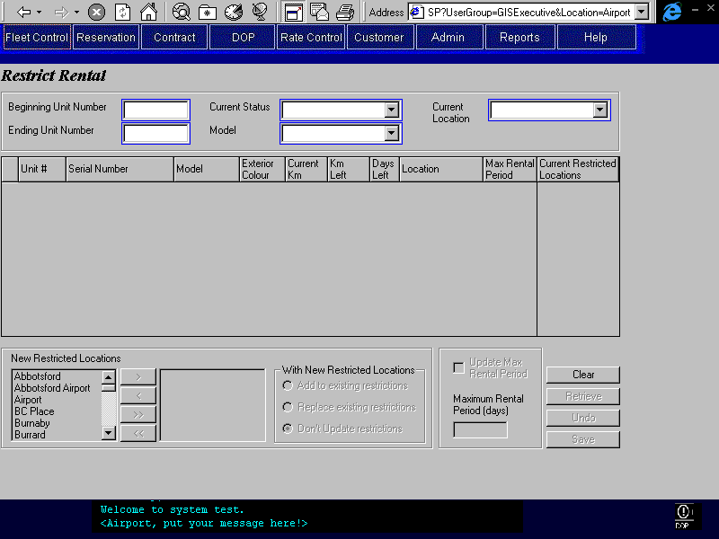

Purpose
The purpose of this screen is to associate locations to a selection of vehicles. These locations will be interpreted as restricted locations for the purposes of vehicle rental and movement. Additionally, a maximum rental period in days can be set for the selected vehicles. This maximum period is commonly used when a vehicle is approaching Turn Back and Budget wants to ensure the vehicles Turn Back limits aren't exceeded while the vehicle is on contract. This screen allows the user to display information about a group of vehicles within a unit number range or with the same model and current status. From this listing of vehicles the user can select multiple entries and update the restricted locations and or the maximum rental period for all selected vehicles.
When updating the restricted locations for a group of vehicles the user can choose to add the New Restricted Locations to the Current Restricted Locations for each vehicle or replace the Current Restricted Locations with the New Restricted Locations. When adding to the Current Restricted Locations, the system will delete from the Current Restricted Locations all locations that appear in the New Restricted Locations list before adding the New Restricted Locations. When replacing the Current Restricted Locations the system will delete all Current Restricted Locations before adding the New Restricted Locations. The user can also select Don’t Update restrictions, which will simply not update the Current Restricted Locations.
When the user checks Update Max Rental Period the Vehicle, Max Rental Period field for all selected vehicles will be updated with the value in Max Rental Period.

Navigation

NA

Functions
Retrieve: Retrieves vehicle records that meet search criteria, within Unit Number range or model and current status, and populates grid.
Save: Updates selected records with new Restricted Locations and new Maximum Rental Periods.

Controls
 | Field | Source | Req* | Validation | Comments
 | Beginning Unit Number | Vehicle, Unit Number | S | 6 digits | When entered Ending Unit Number must also be entered
 | Ending Unit Number | Vehicle, Unit Number | S | 6 digits | When entered Beginning Unit Number must also be entered
 | Current Status | Vehicle, Current Vehicle Status | S | Value controlled by Vehicle Status table | When Unit Number Range not entered one of Current Status, Model, or Current Location is required
 | Model | Vehicle, Vehicle Model ID | S | Value controlled by Vehicle Model Year table | When Unit Number Range not entered one of Current Status, Model, or Current Location is required
 | Current Location | Vehicle, Current Location ID | S | Value controlled by Location table | When Unit Number Range not entered one of Current Status, Model, or Current Location is required
 | Unit # | Vehicle, Unit Number | D
 | Serial # | Vehicle, Serial Number | D
 | Model | Vehicle, Vehicle Model ID | D |  | Display Model Name.
 | Exterior Colour | Vehicle, Exterior Colour | D
 | Current Km | Vehicle, Current Km | D
 | Km Left |  | D |  | (Vehicle, Do Not Rent Past Km – Vehicle, Current Km)
 | Days Left |  | D |  | (Vehicle, Do Not Rent Past Days – (Current Date – Ownership Date))
 | Location | Vehicle, Current Location ID | D |  | Display Location name.
 | Max Rental Period | Vehicle, Maximum Rental Period | D
 | Current Restricted Locations | Vehicle Location Restriction, Location ID | D |  | Displays the restricted locations for the vehicle currently selected. Display Location name.
 | New Restricted Locations | Vehicle Location Restriction, Location ID | S | Value controlled by Location Table | Either New Restricted Location or Maximum Rental Period must be entered
 | Add to existing restrictions |  | N |  | Option – Specifies that the system add the new restrictions
 | Replace existing restrictions |  | N |  | Option – Specifies that the system overwrite the existing restrictions
 | Don’t Update restrictions |  | N |  | Option – Specifies no updating of restricted locations
 | Update Max Rental Period |  | N |  | Checkbox – update Maximum Rental Period when checked, clear Maximum Rental Period and disable when unchecked
 | Maximum Rental Period (days) | Vehicle, Maximum Rental Period | S |  | Either New Restricted Locations or Maximum Rental Period must be entered
Technical Notes
A maximum of 100 vehicles can be updated at one time.
When a single vehicle is selected in the search results grid the restricted locations for that vehicle are displayed in the Current Restricted Locations grid. When multiple vehicles are selected the Current Restricted Locations grid will be empty.

Program Information Update

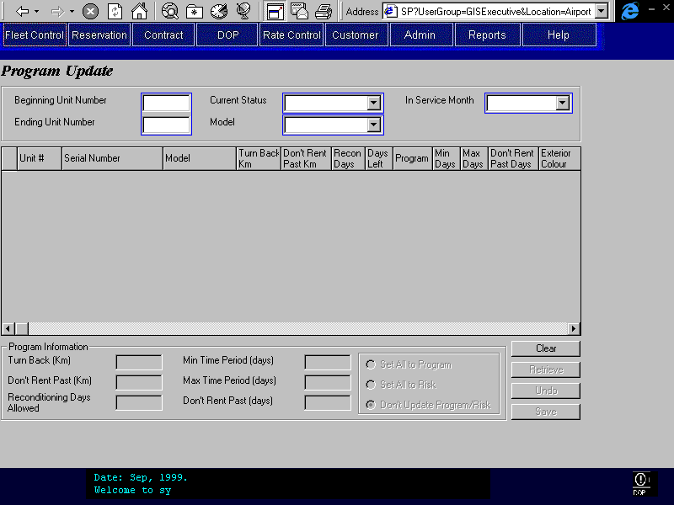

Purpose
This screen allows the user to display information about a group of vehicles within a unit number range or of a specific model with a specific current status. From this listing of vehicles the user can select multiple entries and then update the turn back information of all selected vehicles simultaneously.

Navigation

NA

Functions
Retrieve: Retrieves vehicle records that meet search criteria, within Unit Number range or model and current status, and populates grid.
Save: Updates selected records with new program information.

Controls
 | Field | Source | Req* | Validation | Comments
 | Beginning Unit Number | Vehicle, Unit Number | S | 6 digits | When entered Ending Unit Number required
 | Ending Unit Number | Vehicle, Unit Number | S | 6 digits | When entered Beginning Unit Number required
 | Current Status | Vehicle, Current Vehicle Status | S | Value controlled by Vehicle Status table | When Unit Number Range not entered one of Current Status, Model, or In Service Month is required
 | Model | Vehicle, Vehicle Model ID | S | Value controlled by Vehicle Model Year table | When Unit Number Range not entered one of Current Status, Model, or In Service Month is required
 | In Service Month | Vehicle, Ownership Date | S | MMM YYYY Format, last two years from current month | When Unit Number Range not entered one of Current Status, Model, or In Service Month is required
 | Unit # | Vehicle, Unit Number | D | 6 digits
 | Serial # | Vehicle, Serial Number | D
 | Model | Vehicle, Vehicle Model ID | D |  | Display Model Name.
 | Turn Back Km | Vehicle, Maximum Km | D
 | Don’t Rent Past Km | Vehicle, Do not Rent Past Km | D
 | Recon Days | Vehicle, Reconditioning Days Allowed | D
 | Days Left |  | D |  | (Vehicle, Do Not Rent Past Days – (Current Date – Ownership Date))
 | Program | Vehicle, Program | D |  | Display Program or Risk
 | Min Days | Vehicle, Minimum Days | D
 | Max Days | Vehicle, Maximum Days | D
 | Don’t Rent Past Days | Vehicle, Do Not Rent Past Days | D
 | Exterior Colour | Vehicle, Exterior Colour | D
 | In Service | Vehicle, Ownership Date | D
 | Turn Back (Km) | Vehicle, Maximum Km | N |  | If Null don’t update
 | Don’t Rent Past (Km) | Vehicle, Do Not Rent Past Km | N |  | If Null don’t update
 | Reconditioning Days Allowed | Vehicle, Reconditioning Days Allowed | N |  | If Null don’t update
 | Min Time Period (days) | Vehicle, Minimum Days | N |  | If Null don’t update
 | Max Time Period (days) | Vehicle, Maximum Days | N |  | If Null don’t update
 | Don’t Rent Past (days) | Vehicle, Do Not Rent Past Days | N |  | If Null don’t update
 | Set All to Program | Vehicle, Program | N |  | Set all selected vehicles Program field to True
 | Set All to Risk | Vehicle, Program | N |  | Set all selected vehicles Program field to False
 | Don’t Update Program/Risk |  | N |  | Don’t update Program field
Technical Notes
A maximum of 100 vehicles can be updated at one time.

Vehicle Inventory
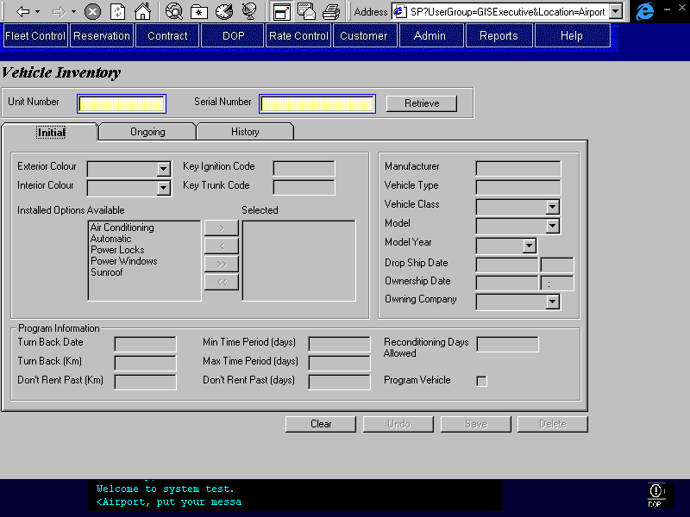

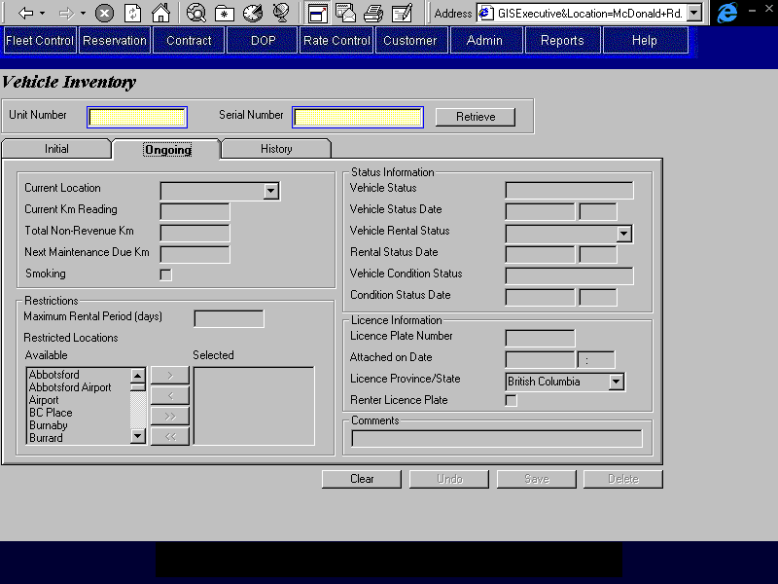

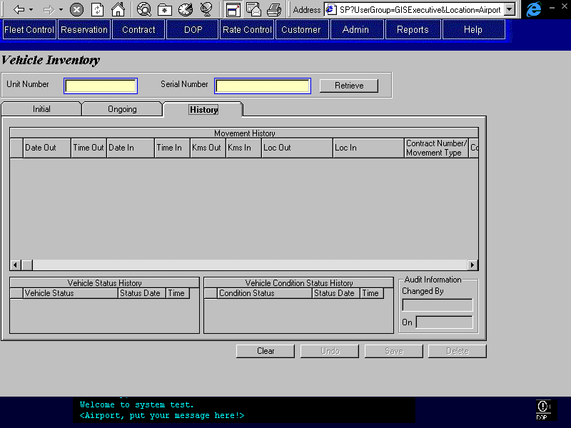
Renter

Purpose
The Vehicle Inventory screen provides the Budget Fleet personnel with a facility for viewing vehicle information and editing specific vehicle information without performing a processing function related to that information. For example the Current Km reading is updated by the Contract and Vehicle movement functions but can still be updated here without having to generate a contract or vehicle movement. Additionally the history for a vehicle can be viewed here, including the vehicle status history, rental history, and condition history.
Most of the information on this screen is set by other screens. It is assumed that this screen will be used infrequently to maintain data on vehicles.
Field | Set by these screens
Current Location | Vehicle Movement, Contract
Current Km Reading | Vehicle Movement, Contract , Vehicle Service
Total Non-Revenue Km | Vehicle Movement
Maximum Rental (days) | Restrict Rental
Restricted Locations | Restrict Rental
Vehicle Status | Add To Inventory, Status Update
Vehicle Status Date | Add To Inventory, Status Update
Rental Status | Status Update, Contract
Rental Status Date | Status Update, Contract
Condition Status | Vehicle Service, Contract, Movement
Condition Status Date | Vehicle Service, Contract, Movement
Licencing Province | Add Foreign Vehicle, Add To Inventory
Licence Plate Number | Add To Inventory, Licence Plate Inventory
Navigation
NA

Functions
Delete: Will set a delete flag for the vehicle but will not remove the vehicle from the database.

Controls
 | Field | Source | Req* | Validation | Comments
 | Unit Number | Vehicle, Unit Number or Foreign Unit Number | S | 6 digits | Either Unit # or Serial # required for retrieval, once retrieved not updateable.  Display Foreign Unit Number if populated otherwise display Unit Number.
 | Serial Number | Vehicle, Serial Number | S | Must be exactly 17 characters longs. For retrieval the last 6 digits can be entered. | Either Unit # or Serial # required for retrieval
 | Initial Tab
 | Exterior Colour | Vehicle, Exterior Colour | Y | Value controlled by lookup table
 | Interior Colour | Vehicle, Interior Colour | N | Value controlled by lookup table
 | Key Ignition Code | Vehicle, Key Ignition Code | S |  | Required if vehicle owning company is BRAC BC.
 | Key Trunk Code | Vehicle, Key Trunk Code | N
 | Installed Options | Vehicle Installed Option, Vehicle Option ID | N | Value controlled by Vehicle Option table
 | Manufacturer | Vehicle, Vehicle Model ID; | D |  | Display Manufacturer name for Vehicle Model Year, Manufacturer ID
 | Vehicle Type | Vehicle, Vehicle Model ID; | D |  | Display Vehicle Type associated with Vehicle Model Year, Vehicle Class Code.
 | Vehicle Class | Vehicle, Vehicle Model ID; | Y | Value controlled by Vehicle Class table | Display Vehicle Class Name for Vehicle Model Year, Vehicle Class Code.
 | Model | Vehicle, Vehicle Model ID | Y | Value controlled by Vehicle Model Year table | Display Model Name.
 | Model Year | Vehicle, Vehicle Model ID | S | Value controlled by Vehicle Model Year table | Required if the vehicle model is a not a foreign model, not enterable if the vehicle model is foreign.  Display Model Year
 | Drop Ship Date | Vehicle, Drop Ship Date | D
 | Ownership Date | Vehicle, Ownership Date | N | Date/Time Format | Editable if no movement history and the vehicle owning company is BRAC BC.
 | Owning Company | Vehicle, Vehicle Owning Company | Y | Value controlled by Owning Company table
 | Turn Back Date | Vehicle, Turn Back Deadline | N | Date Format
 | Turn Back (Km) | Vehicle, Maximum Km | N
 | Don’t Rent Past (Km) | Vehicle, Do Not Rent Past Km | N
 | Min Time Period (days) | Vehicle, Minimum Days | N
 | Max Time Period (days) | Vehicle, Maximum Days | N
 | Don’t Rent Past (days) | Vehicle, Do Not Rent Past Days | N
 | Reconditioning Days Allowed | Vehicle, Reconditioning Days Allowed | N
 | Program Vehicle | Vehicle, Program | N
 | Ongoing Tab
 | Current Location | Vehicle, Current Location ID | Y | Value controlled by Location table
 | Current Km Reading | Vehicle, Current Km | Y
 | Total Non-Revenue Km | Vehicle, Total Non-Revenue Km | N |  | Not enterable if the vehicle owning company is not BRAC BC.
 | Next Maintenance Due Km | Vehicle, Next Scheduled Maintenance | N |  | Not enterable if the vehicle owning company is not BRAC BC.
 | Smoking | Vehicle, Smoking | N |  | Not enterable if the vehicle owning company is not BRAC BC.
 | Maximum Rental Period (days) | Vehicle, Maximum Days | N |  | Not enterable if the vehicle owning company is not BRAC BC.
 | Restricted Location | Vehicle Location Restriction, Location ID | N |  | Accumulator  Not enterable if the vehicle owning company is not BRAC BC.
 | Vehicle Status | Vehicle, Current Vehicle Status | D
 | Vehicle Status Date | Vehicle, Vehicle Status Effective On | D
 | Vehicle Rental Status | Vehicle, Current Rental Status | Y | Value controlled by Vehicle Rental Status table. | If value changed in this field will not update Rental Status Date.
 | Rental Status Date | Vehicle, Rental Status Effective On | D
 | Vehicle Condition Status | Vehicle, Current Condition Status | D
 | Condition Status Date | Vehicle, Condition Status Effective On | D
 | Licence Plate Number | Vehicle, Current Licence Plate | S |  | Required when Attached on Date is entered
 | Attached on Date | Vehicle, Licence Plate Attached On | S | Date/Time  Cannot be less than Drop Ship date. | Required when Licence Plate Number is entered
 | Licence Province/State | Vehicle, Current Licencing Province/State | S | Value controlled by Province/State table. | Required when Licence Plate Number is entered
 | Renter Licence Plate | Vehicle, Foreign Licence Plate | N |  | Don’t save plate to Licence Inventory.  Display only if vehicle owning company is not BRAC BC.
 | Comments | Vehicle, Comments | N |  | Memo field
 | History Tab
 | Movement History – for details see the Movement History section of the Vehicle Movement screen in this document
 | Date Out | Movement or Contract | D
 | Time Out | Movement or Contract | D
 | Date In | Movement or Contract | D
 | Time In | Movement or Contract | D
 | Kms Out | Movement or Contract | D
 | Kms In | Movement or Contract | D
 | Location Out | Movement or Contract | D
 | Location In | Movement or Contract | D
 | Contract # or Movement type | Movement or Contract | D
 | Comments | Movement or Contract | D
 | Vehicle Status History
 | Vehicle Status | Vehicle History, Vehicle Status | D
 | Status Date and Time | Vehicle History, Effective On | D
 | Vehicle Condition Status History
 | Condition Status | Condition History, Condition Status | D
 | Status Date and Time | Condition History, Effective On | D
 | Audit Information
 | Changed By | Vehicle, Last Updated By
 | On | Vehicle Last Updated On
Technical Notes
The Ownership Date is editable for vehicles that have no movement history, that is they have never been rented or moved. If edited the system will also update the status date where the status is “Owned” and the attached on date for the licence plate.
The History tab displays historical information on a vehicle’s movement history, status history, and condition status history. The movement history comprises two different transactions. A contract where the contract number is displayed, and a vehicle movement where the movement type is displayed. The movement history is ordered by Date Out in descending order. The status history is retrieved from the Vehicle History table and displays the life cycle for the vehicle. It is ordered by date in descending order. The condition status history will display the vehicle’s condition at any time during its life at Budget. It is also ordered by date in descending order.
The Renter Licence plate checkbox is checked for Budget BC vehicles on long term rentals where the renter is supplying the vehicle insurance and plates. In this case we don’t want the licence to appear in the Budget BC licence inventory. Additionally, if the vehicle is a Foreign Vehicle we don’t want to save the licence plate to the Licence inventory.
Condition | Save Licence To Vehicle Record | Save Licence To Licence Inventory
Budget BC Vehicle & Budget BC Licence | Yes | Yes
Budget BC Vehicle & Renter Licence | Yes | No
Foreign Vehicle & Foreign Licence | Yes | No
When a vehicle is retrieved that doesn’t have a licence plate attached to it a licence can be added to the vehicle in this screen. On save the system will save the licence information. Additionally, if the vehicle’s current status id “Drop Ship” the system will update the Vehicle Status to “Owned” and save the Ownership Date. A vehicle that already has a licence attached cannot have its licence information edited in this screen. The licence would have to be removed from the vehicle in the Licence Inventory screen.
When the rental status is changed through this screen, the rental status effective date will not be updated.

Licence Plate Inventory
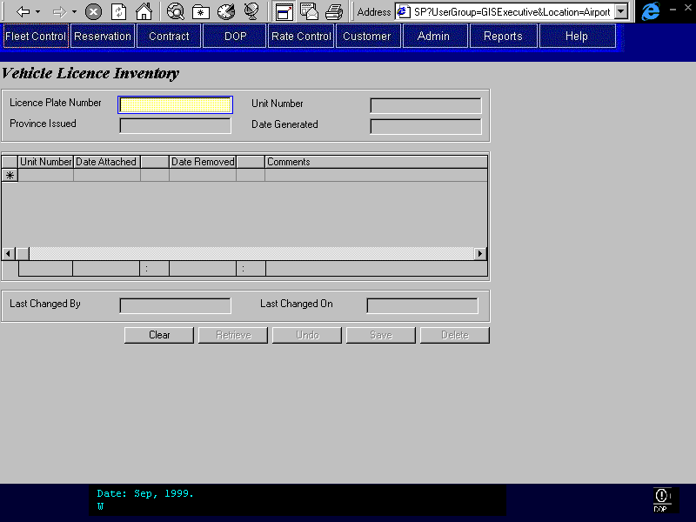

Purpose
This screen is used to view licence plate history and to attach or remove licence plates. The user enters an individual plate number and presses the retrieve command button and a detailed history for that Licence plate is displayed. The user can then edit the record and save any changes.

Navigation

NA

Functions
Save: See Technical Notes.

Controls
 | Field | Source | Req* | Validation | Comments
 | Licence Plate Number | Vehicle Licence Plate, Licence Plate Number | Y |  | Searchable
 | Province Issued | Vehicle Licence Plate, Licencing Province/State | D
 | Unit Number | Vehicle Licence History, Unit Number | D |  | Display Unit Number with latest Attached On date where Removed On is not populated.
 | Date Generated | Vehicle Licence Plate, Created On | D | Date Format
 | Attached Vehicles |  |  |  | In the upper part of the grid show the vehicles that have been historically attached to this licence plate (Removed On date populated). On the row that appears at the bottom of the grid display the vehicle currently attached to the licence plate (Removed On date not populated).
 | Unit Number | Vehicle Licence History, Unit Number | Y |  | Enterable if Vehicle Licence History, Removed on is not populated, otherwise display only.
 | Date Attached | Vehicle Licence History, Attached On | Y | Date/Time Format  Cannot be less than Drop Ship date for vehicle. | Enterable if Vehicle Licence History, Removed on is not populated, otherwise display only.
 | Date Removed | Vehicle Licence History, Removed On | S | Date/Time  Only one blank entry allowed  Vehicle cannot have a rental status of “In Transit” and cannot have a rental status of “On Rent” unless a vehicle not present check in has been done by vehicle support. | Enterable if Vehicle Licence History, Removed on is not populated, otherwise display only.
 | Comments | Vehicle Licence History, Comment | N |  | Enterable if Vehicle Licence History, Removed on is not populated, otherwise display only.
 | Last Changed By | Vehicle Licence Plate, Last Changed By | D
 | Last Changed On | Vehicle Licence Plate, Last Changed On | D
Technical Notes
The licence plate history should display ordered descending by Date Attached.
When a Date Removed is entered and saved the system will write the Date Removed to the appropriate entry in the Vehicle Licence Plate table. Additionally the system will delete the licence plate number from the vehicle record.
When a new Unit Number and a Date Attached is entered the system will:
      - Check that the vehicle doesn’t already have a licence plate associated with it and display a message if it does.
      - Check that the licence plate is not still attached to a vehicle and display a message if it is.
      - Check that the status for the vehicle, if it is “Drop Ship” then set the status to “Owned” and the Status Date to Date Attached, set the Current Licence Plate and Issuing Province, set the Ownership Date for the vehicle and create a Vehicle History record.

Licence Plate Generation
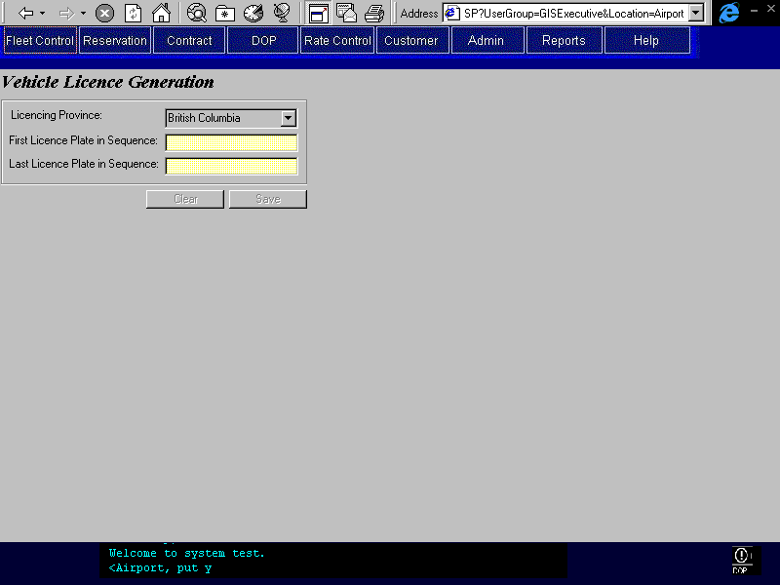

Purpose
The Licence Plate Generation screen allows users to create multiple sequential Licence plate entries in the database without having to enter each one individually. The user enters the first and last number in the sequence and the system generates an entry for each individual plate. The screen will work with numeric sequences only but for both car and truck Licence plates.
Example:
Cars Beginning Plate Number: ABC 120
Ending Plate Number: ABC 125
Will generate plates ABC 120, ABC 121, ABC 122, ABC 123, ABC 124, and ABC 125.
Trucks Beginning Plate Number: 2114 FT
Ending Plate Number: 2120 FT
Will generate plates 2114 FT, 2115 FT, 2115 FT, 2117 FT, 2118 FT, 2119 FT, and 2120 FT.

Navigation

NA

Functions
Save: Executes the Create Sequential Licence Plates function passing the beginning and ending licence plate numbers.

Controls
 | Field | Source | Req* | Validation | Comments
 | Licencing Province | Vehicle Licence Plate, Licencing Province/State | Y | Value controlled by Lookup table | Default to BC
 | First Licence Plate in Sequence | Vehicle Licence Plate, Licence Plate Number | Y | Must be either car or truck Licence plate format AAA 999 or 9999 AA
 | Last Licence Plate in Sequence | Vehicle Licence Plate, Licence Plate Number | Y | Must be either car or truck Licence plate format AAA 999 or 9999 AA
Technical Notes
On save the system will invoke a function called Create Licence Entries. This function will create the individual records in the Vehicle Licence Plate table based on the beginning and ending sequence numbers. When the function is complete a message box will be displayed informing the user how many entries were created or conversely if an error occurred.
The following fields will be written to each record;
- Licence Plate Number
- Licencing Province/State
- Created On(system date)

Vehicle Search – Single Record
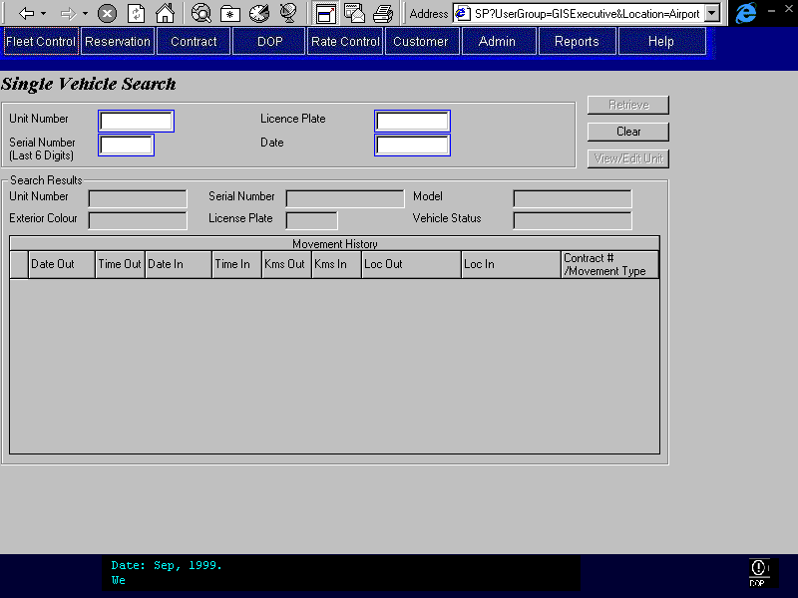

Purpose
This screen allows users to search for vehicle information based on Unit Number or Serial Number. The user can also specify a Licence Plate Number and a date to determine what vehicle the Licence plate was attached to on that date. This second search is used to assist with the processing of traffic violations, which don’t specify the unit number of the vehicle.

Navigation
View/Edit Unit: This button opens the Vehicle Inventory screen with the selected record displayed.

Functions
Retrieve: The vehicle information will load displaying the results of the search. The most recent movement history for the vehicle would also be displayed.

Controls
 | Field | Source | Req* | Validation | Comments
 | Unit Number | Vehicle, Unit Number | S | 6 digits
 | Serial Number | Vehicle, Serial Number | S |  | last 6 digits
 | Licence Plate | Vehicle Licence History, Licence Plate Number | S |  | Required with Date
 | Date | Vehicle Licence History, Attached On and Removed On | S |  | Required with Licence The date the Licence was on the vehicle
 | Unit Number | Vehicle, Unit Number | D
 | Serial Number | Vehicle, Serial Number | D
 | Model | Vehicle, Vehicle Model ID | D |  | Display Model Name.
 | Exterior Colour | Vehicle, Exterior Colour | D
 | Licence Plate | Vehicle, Current Licence Plate | D
 | Vehicle Status | Vehicle, Current Vehicle Status | D
 | Movement History – for details see the Movement History section of the Vehicle Movement screen in this document
 | Date Out | Contract or Movement | D
 | Time Out | Contract or Movement | D
 | Date In | Contract or Movement | D
 | Time In | Contract or Movement | D
 | Kms Out | Contract or Movement | D
 | Kms In | Contract or Movement | D
 | Loc Out | Contract or Movement | D
 | Loc In | Contract or Movement | D
 | Contract # or Movement type | Contract or Movement | D
Technical Notes
The movement history comprises two different transactions. A contract where the contract number will be displayed, and a vehicle movement where the movement type will be displayed. All other information, date out, time out, date in, time in, kilometres out, kilometres in, location out, and location in will be stored for both transaction types.

Vehicle Search Multiple records
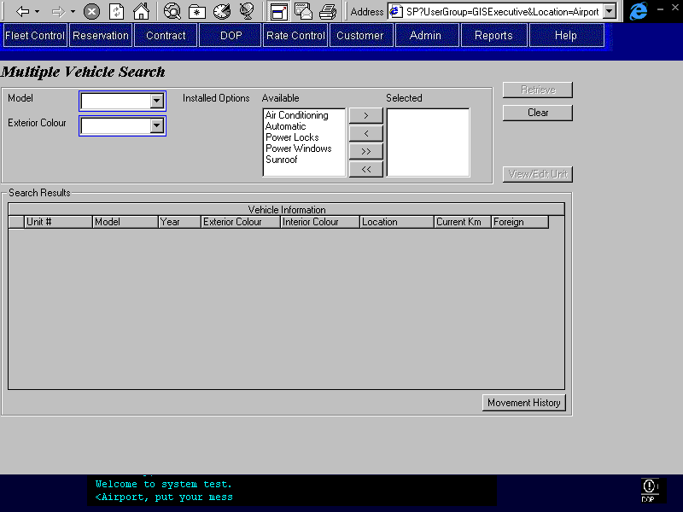

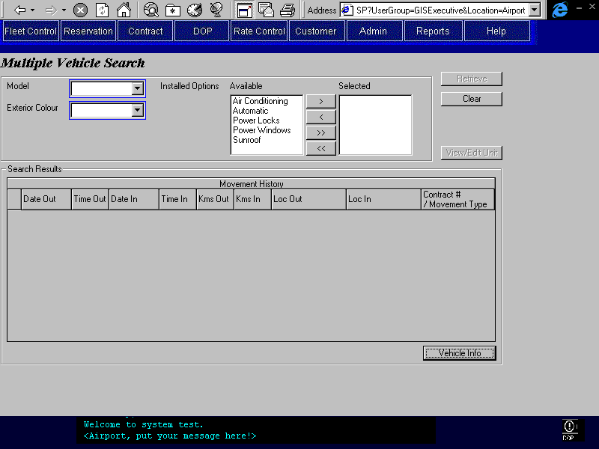

Purpose
This screen allows users to search for vehicle information based on vehicle model, exterior colour, and installed options. The search takes the form of an AND condition, that is it returns all records where the Model, Exterior Colour, AND ALL of the selected options apply.
Example: Model: Contour
Colour Blue
Options: AC, Air Bag Driver, CD Player
Won’t Return:

Model Colour Options
Contour Blue AC, Air Bag Driver, Cassette
Contour Green AC, Air Bag Driver, CD Player
Taurus Blue AC, Air Bag Driver, CD Player
This would return all blue Contours with Air Conditioners, Driver’s Air Bag, AND a CD Player. Vehicles missing even one option would not be returned.
This search returns multiple records if more than one vehicle matches the search criteria. This search would be used to locate a specific type of vehicle, usually to satisfy a customer request.

Navigation
View/Edit Unit: This button opens the Vehicle Inventory screen with the selected record displayed.

Functions
Retrieve: The vehicle information search results will be displayed in a grid. The user selects the record from the grid and then they click on the history button to view the vehicle’s movement history. If too many records meet the criteria, for example more than 100 records, then the system will prompt the user to refine their search criteria.
History: The History button will display the most recent movement history for the vehicle currently selected in the Vehicle Information grid. This button will not display when the Movement History grid is already displayed.
Vehicle Information: The Vehicle Information button will display a list of vehicle records that match the user’s search criteria. This button will not display when the Vehicle Information grid is already displayed.

Controls
 | Field | Source | Req* | Validation | Comments
 | Model | Vehicle, Vehicle Model ID | S | Value controlled by Model Year table
 | Exterior Colour | Vehicle, Exterior Colour | S | Value controlled by lookup table
 | Installed Options | Vehicle Installed Option, Vehicle Option ID | S | Value controlled by Vehicle Options table | Accumulator
 | Vehicle Information
 | Unit # | Vehicle, Unit Number | D
 | Model | Vehicle, Vehicle Model ID | D |  | Display Model Name.
 | Year | Vehicle, Vehicle Model ID | D |  | Display Model Year.
 | Exterior Colour | Vehicle, Exterior Colour | D
 | Interior Colour | Vehicle, Interior Colour | D
 | Location | Vehicle, Current Location ID | D |  | Display Location name.
 | Current Km | Vehicle, Current Km | D
 | Foreign | Vehicle, Foreign Unit Number | D |  | Display ‘Foreign’ if Vehicle, Foreign Unit Number is populated, blank otherwise
 | Movement History – for details see the Movement History section of the Vehicle Movement screen in this document.
 | Date Out | Contract or Movement | D
 | Time Out | Contract or Movement | D
 | Date In | Contract or Movement | D
 | Time In | Contract or Movement | D
 | Kms Out | Contract or Movement | D
 | Kms In | Contract or Movement | D
 | Loc Out | Contract or Movement | D
 | Loc In | Contract or Movement | D
 | Contract # or Movement Type | Contract or Movement | D
Technical Notes
The movement history comprises two different transactions. A contract where the contract number will be displayed, and a vehicle movement where the movement type will be displayed. All other information, date out, time out, date in, time in, kilometres out, kilometres in, location out, and location in will be stored for both transaction types.

Vehicle Model/Year
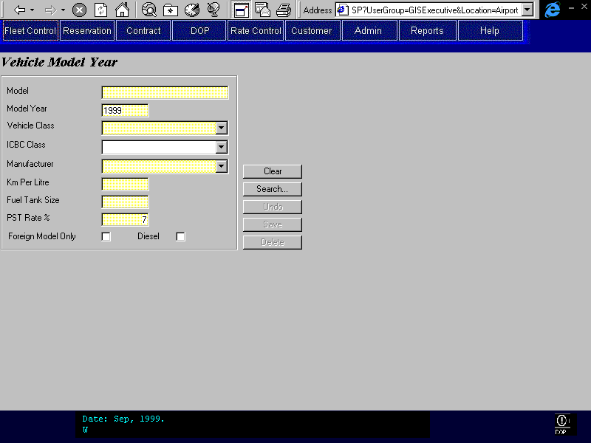

Purpose
A screen for maintaining information on vehicle models. The screen allows authorised users to view, add, edit, and delete vehicle models. Additionally, the user can search the models currently stored in the system by pressing the Search button. The Model Year Search dialog would then appear allowing the user to search by model name, model year, and vehicle class. The search results are initially displayed in the grid. The user selects the specific model from the grid, presses Select, and the model is then displayed in the Model/Year screen.

Navigation
Search: Opens the Vehicle Model year Search screen allowing the user to search the Model/Year table for records matching their criteria.

Functions
Delete: Models that already have vehicles attached to them cannot be deleted. The delete function is primarily for deleting incorrectly entered models or discontinued models.

Controls
 | Field | Source | Req* | Validation | Comments
 | Model | Vehicle Model Year, Model Name | Y
 | Model Year | Vehicle Model Year, Model Year | Y |  | Defaults to Current Year
 | Vehicle Class | Vehicle Model Year, Vehicle Class Code | Y | Value controlled by vehicle class table | Display Vehicle Class Name
 | ICBC Class | Vehicle Model Year, ICBC Vehicle Class Code | Y | Value controlled by vehicle class table | Defaults to Vehicle Class.  Display Vehicle Class Name.
 | Manufacturer | Vehicle Model Year, Manufacturer ID | Y | Value controlled by Vehicle Manufacturer table | Display Manufacturer name.
 | Km Per Litre | Vehicle Model Year, Km Per Litre | Y
 | Fuel Tank Size | Vehicle Model Year, Fuel Tank Size | Y |  | litres
 | PST Rate % | Vehicle Model Year, PST Rate | Y | Percent
 | Foreign Model Only | Vehicle Model Year, Foreign Model | N |  | Only model name and vehicle class required when true
 | Diesel | Vehicle Model Year, Diesel | N |  | Separate Models for diesel vehicles
Model Year Search screen
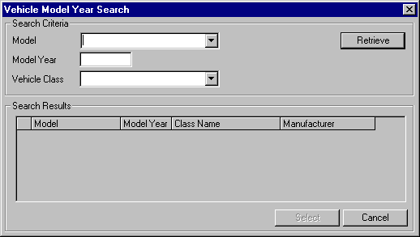

Controls
 | Field | Source | Req* | Validation | Comments
 | Model | Vehicle Model Year, Model Name | S | Value controlled by Vehicle Model Year table | One of Model, Model Year, or Class Name required
 | Model Year | Vehicle Model Year, Model Year | S |  | One of Model, Model Year, or Class Name required
 | Vehicle Class | Vehicle Model Year, Vehicle Class Code | S | Value controlled by Vehicle Class table | One of Model, Model Year, or Class Name required  Display Vehicle Class Name.
 | Model | Vehicle Model Year, Model Name | D
 | Model Year | Vehicle Model Year, Model Year | D
 | Class Name | Vehicle Model Year, Vehicle Class Code | D |  | Display Vehicle Class Name
 | Manufacturer | Vehicle Model Year, Manufacturer ID | D |  | Display Manufacturer name.

Vehicle Class Maintenance
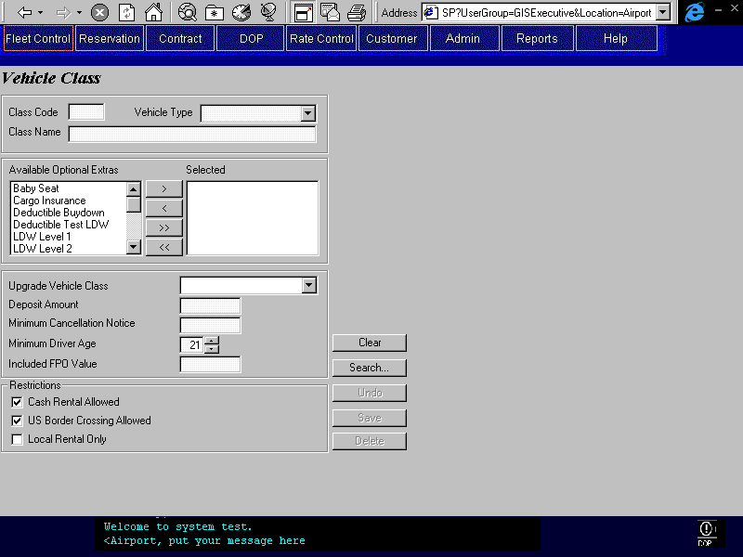

Purpose
A screen for maintaining basic information on vehicle classes. The screen allows authorised users to view, add, edit, and delete vehicle classes. Additionally, the user can search the classes currently stored in the system by pressing the Search button. The Vehicle Class Search dialog then appears allowing the user to search by class code, class name, and vehicle type. The search results are initially displayed in the grid. The user selects the specific class from the grid, presses Select, and the class is then displayed in the Vehicle Class screen.

Navigation
Search: Opens the Vehicle Class Search screen allowing the user to search the Vehicle Class table for records matching their criteria.

Functions

Delete: Classes that already have models attached to them cannot be deleted.Controls
 | Field | Source | R | Validation | Comments
 | Class Code | Vehicle Class, Vehicle Class Code | Y
 | Vehicle Type | Vehicle Class, Vehicle Type | Y | Value controlled by Vehicle Type table.
 | Class Name | Vehicle Class, Vehicle Class Name | Y
 | Available Optional Extras | Optional Extra Restriction, Optional Extra ID | N | Value controlled by Optional Extras table | Allows selection of one or more options. Optional extras not selected will be saved in the Optional Extra Restriction table.
 | Upgrade Vehicle Class | Vehicle Class, Upsell Vehicle Class Code | N | Value controlled by Vehicle Class table
 | Deposit Amount | Vehicle Class, Deposit Amount | Y | Currency
 | Minimum Cancellation Notice | Vehicle Class, Minimum Cancellation Notice | Y | Integer (No. of days)
 | Minimum Driver Age | Vehicle Class, Minimum Age | Y | Must be > or = 19 | Defaults to 21
 | Included FPO Value | Vehicle Class, Included FPO Amount | Y | Currency
 | Cash Rental Allowed | Vehicle Class, Cash Rental Allowed | N |  | Default to Yes  Note that this is for information purposes only and is not used by the Contract screens.
 | US Border Crossing Allowed | Vehicle Class, US Border Crossing Allowed | N |  | Default to Yes
 | Local Rental Only | Vehicle Class, Local Rental Only | N |  | Default to No
Vehicle Class Search screen
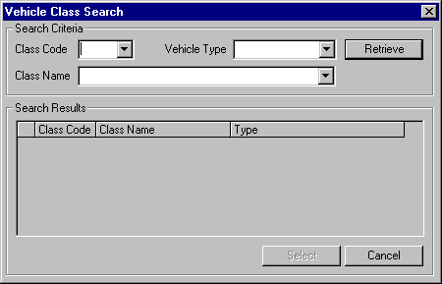

Controls
 | Field | Source | R | Validation | Comments
 | Class Code | Vehicle Class, Vehicle Class Code | S | Value controlled by Vehicle Class table | One of Class Code, Class Name, or Vehicle Type required
 | Class Name | Vehicle Class, Vehicle Class Name | S | Value controlled by Vehicle Class table | One of Class Code, Class Name, or Vehicle Type required
 | Vehicle Type | Vehicle Class, Vehicle Type | S | Value controlled by Vehicle Type table | One of Class Code, Class Name, or Vehicle Type required
 | Class Code | Vehicle Class, Vehicle Class Code | D
 | Class Name | Vehicle Class, Vehicle Class Name | D
 | Type | Vehicle Class, Vehicle Type | D

Owning Company Maintenance
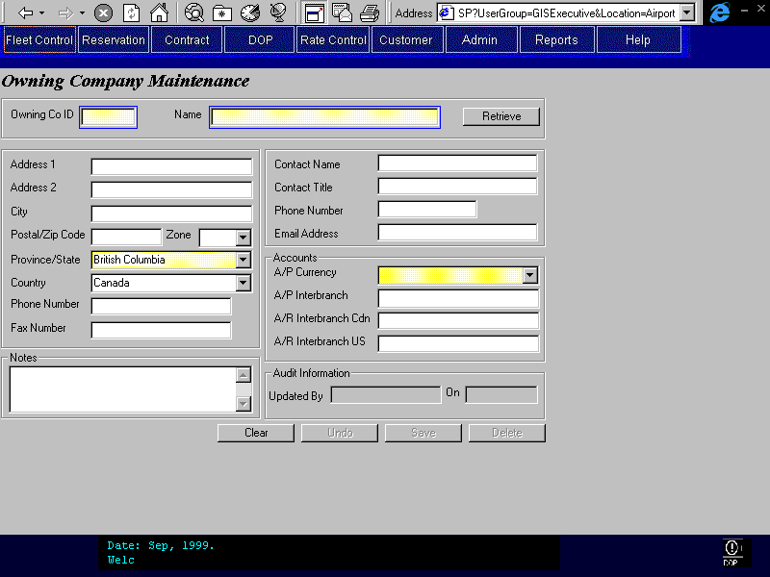

Purpose
A screen for maintaining basic information on Owning Companies. This screen would most likely be accessed infrequently and by very few personnel. The user would be able to search the Owning Companies currently stored in the system by Owning Company ID and Owning Company Name. If more than one record matched a query then the results would initially be displayed in a grid. The user would select the specific record from the grid and it would then be displayed in the Owning Company screen.

Navigation

NA

Functions
Delete: Sets a delete flag for the Owning Company but does not remove it from the database.

Controls
 | Field | Source | Req* | Validation | Comments
 | Owning Co ID | Owning Company, Owning Company | Y | 4 Digits
 | Name | Owning Company, Name | Y | Text
 | Address 1 | Owning Company, Address 1 | N
 | Address 2 | Owning Company, Address 2 | N
 | City | Owning Company, City | N
 | Postal/Zip Code | Vehicle Owner, Postal Code | N | Must accept both Canadian and US postal codes
 | Province/State | Owning Company, Province | N | Value controlled by lookup table | Default to BC  User can enter a value not in the list
 | Country | Owning Company, Country
 | Zone | Owning Company, Zone | N | 0-5
 | Phone Number | Owning Company, Phone Number | N
 | Fax Number | Owning Company, Fax Number | N
 | Contact Name | Owning Company, Contact Name | N
 | Contact Title | Owning Company, Contact Position | N
 | Contact Phone Number | Owning Company, Contact Phone Number | N
 | Email Address | Owning Company, Contact Email Address | N
 | A/P Currency | Owning Company, A/P Currency ID | Y | Either “Canadian” or “US”
 | A/P Interbranch | Owning Company, A/P Interbranch Account | N |  | Account Number
 | A/R Interbranch Cdn | Owning Company, A/R Interbranch Canadian Account | N |  | Account Number
 | A/R Interbranch US | Owning Company, A/R Interbranch US Account | N |  | Account Number
 | Updated By | Owning Company, Last Updated By | D
 | On | Owning Company, Last Updated On | D
 | Notes | Owning Company, Remarks | N
Technical Notes
Audit information, Last Changed By and Last Changed On, is written to the database each time an Owning Company is edited.

Reports
All fleet reports are defined in the GIS Reports business design documents.

Test Scenario List
            - Add a vehicle to the fleet.
            - Record the Transfer of Ownership for a Budget BC vehicle(s).
            - Record the Placement of a vehicle(s) in the rental or lease fleets.
            - Record the Update of a vehicle(s)’ status to Held, Pulled for Sale, Pulled for Turn Back, Sold, etc.
            - Search for a Licence Plate.
            - Generate Licence Plates.
            - View the Licence Inventory and specific Licence History.
            - Search for a single vehicle using:
- last 6 digits of serial number
- Unit Number Or
- Licence Plate
- And Date
            - Search for multiple vehicles using combinations of:
- Model
- Exterior Colour
- Installed Options
            - Add, Update and Delete records for:
- Vehicle Model/Year
- Vehicle Class
- Owning Company
            - Update a vehicle(s) Turn Back Information
            - Record a Vehicle Movement – Send and Receive
            - Record a Vehicle Service
            - Restrict a vehicle(s) rental locations and maximum rental period
            - Add a Foreign Vehicle into Inventory
            - Update a vehicle record

Controls & Audit Trails
Controls and audit trails are built into the individual screens as described above.

Security Requirements
The security requirements for all of GIS (including fleet) are documented in the GIS Security business design document.

Business Transaction Volumes
Transaction | Average | Peak
Add Vehicle to Inventory |  | 100-150 day
Update Vehicles | 60-75 at once / day | 60-75 at once / day
The transaction volumes for the fleet control functions within the GIS system are not anticipated to be high as compared to the transactional processing functions of the system.

Tables without Maintenance Screens
This section has been superseded by the Production System Maintained Tables document.
- Vehicle Status
- Condition Status
- Rental Status
- Vehicle Type
- Manufacturer
- Dealer
- Exterior Colour
- Interior Colour

System Values Table Entries
This section has been superseded by the Production System Maintained Tables document.
- Maximum Allowed Km Discrepancy
This figure represents the maximum allowed kilometre difference between the check-in reading and the reading during vehicle service. If the difference is greater than the Maximum Allowed Km Discrepancy amount then the user is prompted to recheck the Current Km reading for an error. Unresolved discrepancies are included in the Unreported Kilometres Report.
- Non-Budget Location
A dummy location used for vehicles that are located at a location that is not a Budget Rent-a-Car location (e.g. the ICBC lot, a car dealership).

Data Model
See the Budget ER1 logical data model.

Revision History

Version 2.00
- Clean up documentation and make consistent with the GIS standards.

